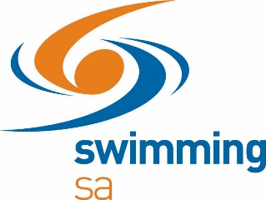

DEVELOPMENT MEETS
What is a Development Meet?
A Development Meet is an opportunity for all swimmers aged 11 & Under and swimmers aged 12 & Over who have not achieved a Division 1 break time to compete for improvement points. This meet falls into the development strand of the new competition structure and will occur once each LC and SC season.
The aim of a Development Meet is to reward swimmers who improve on their personal best rather than focusing attention on those swimmers who place in the top 10 of their event.
How does it work?
The scoring for a Development Meet is listed below:
 | Points Awarded
Improvement on Seed Time | Improvement | Participation | Total
5 sec + | 10pts | 1pt | 11pts
4 sec – 4.99 sec | 9pts | 1pt | 10pts
3 sec – 3.99 sec | 8pts | 1pt | 9pts
2.50 sec – 2.99 sec | 7pts | 1pt | 8pts
2 sec – 2.49 sec | 6pts | 1pt | 7pts
1.50 sec – 1.99 sec | 5pts | 1pt | 6pts
1 sec – 1.49 sec | 4pts | 1pt | 5pts
0.70 sec – 0.99 sec | 3.5pts | 1pt | 4.5pts
0.40 sec – 0.69 sec | 3pts | 1pt | 4pts
0.20 sec – 0.39 sec | 2.5pts | 1pt | 3.5pts
0.10 sec – 0.19 sec | 2pts | 1pt | 3pts
0.05 sec – 0.09 sec | 1.5pts | 1pt | 2.5pts
0.00 sec – 0.04 sec | 1pt | 1pt | 2pts
Slower than Seed Time | 0pts | 1pt | 1pt
Entered with No Time | 0pts | 1pt | 1pt

Instead of swimmers being awarded points based on their place, swimmers will be awarded a participation point and further points based on how much they improve on their seed time.
Points scored at Development Meets also count towards Development Series Pointscores.

